**1969**

The money goes out faster than it comes in. Even Mom gets the measles. There is ice-skating, swimming, kite flying, swimming, raft building, swimming, and sometimes even hiking. Dad does not hear any of us practice. He does not build the bunk beds. He does not learn to spell rehearsal. He *does* yearn for time to write. He panels cautiously and gives drug advice confidently. Mom’s enthusiasm for her choirs dwindles. The girls swim like fish. Andy achieves “big kid” status. Alan’s Christmas crystal radio is not functional until October because… ”time seems to slip by so quickly.”

**1-11-69 – Sat PM -** Dear Mother, Aunt Clara, M.J. & Bill, I must get back on my regular writing schedule after the holiday season disruption. We were glad to have your letter today. We’re having zero weather again today. The 3 older kids got ice skates for Christmas (Alan’s for his birthday) but its too cold for them (danger of frost bite) when it gets down around zero. We did have some more moderate temperatures last week so they got some good skating in. Alan is just learning. I’ve never seen any of them skate; they go over to the school yard where they flood an area for skating. Andy got a new tricycle for his birthday and I put it together this morning. We’re letting him ride it around the house; it’s too cold to ride it outside.

Our furnace isn’t very effecient anymore and the temperature has dropped down to 64 (with the thermostat set high) in the front part of the house on these zero days. The furnace in the back part of the house is more efficieint and keeps the temperature 10 degrees higher back there. If our front furnace (its the original – about 14-15 yrs old) gets through the winter we’ll have it gone over completely before next year. We hope it hasn’t been too cold for you folks.

We thank you all again for the gifts. I’ve worn the slipper socks a lot and have also worn the tie. As I told you we took the cash gifts and Ruth bought an autoharp. They just happened to have the best model in stock because the person who had ordered it decided it was too expensive. They sold it to Ruth for about $60 which was less than they were going to sell it for. Ruth is out to the grocery store now and is stopping by to pick up the autoharp case which she ordered.

As I told you the Laidigs did not come around Christmas because of the flu. They were going to stop by here on the way to New Jersey for Christmas at John’s. They were then planning to go to Miami to visit that sister (Aunt Lenore) of Mrs. L and to attend the orange bowl game. I visited Aunt Lenore in Miami, you may remember. I listened to Orange Bowl game and that was certainly an exciting finish, and it was disappointing to hear KU lose after they seemed to have the game won. I listened to some of the other games while I did some work (We got off at 3:00 PM last Tues and were off on New Years Day). New Years Eve was subzero and we were glad we weren’t trying to go anywhere. We had birthday suppers for the boys on Mon and Tues nights and then they opened their presents. Both boys also had birthday partys during the day. Lesle had the flu and was just getting over it in time for the boys to have partys. Flu and sickness seems to now be on the decline in this area. Hope you folks all escape it.

Ruth had a flat tire while she was out Mon so Mon night I had to take the car in. It was good I did because we needed other work done and the anti-freeze was low. It got very cold later that night. Tues night (New Years Eve) we just watched TV etc. and let the kids stay up late. Alan worked on his Apollo Saturn model which he got for his birthday. He is thrilled with all the space things and events; he got several space related models, etc. and has them all put together. He doesn’t always read the directions, but does a pretty good job for his age.

The Laidigs do plan to come this way after the flu subsides. I have more responsibility at work so I have all I can handle. I’ll let you know later about the possibility my (or the family) taking the train to Hutchinson Feb 8th and then my attending the meeting in Kansas City on Feb 10th & 11. Everything is ready for the appearance of the Millikin University Choir at our morning worship service on Feb 2nd. The choir arrives from the Loop in the morning and the adult s.s. class will have a coffee for them right before the service. The choir members will be taken to homes for lunch and then they leave for an afternoon concert at McCormick (Presbyterian Seminary in Chicago). We’ll have the Hofflands for lunch.

The enclosed pictures are for you and Aunt Clara. They are marked. The 3 older kids pictures are the regular ones taken at school. I have some other things to send under separate cover. The kids have written “Thank You” notes and I’ll take them when I go to mail this letter.

Ruth’s Crusader Choir sings tomorrow. They were to have sung last Sun but they decided to have Communion so we had a quartet instead. I did not have to help serve Communion since I sang in the quartet. I helped dry the grape juice glasses afterwards and it reminded me of times when I was a boy and Dad was helping wash and dry the Communion glasses after a Communion service.

I certainly remember the Rose Parade. Aunt Lenore drove me by the Orange Bowl in Miami so I can say that I’ve see all 4 major bowls. We saw the Rose, Cotton and Sugar Bowls when we were on our 3 trips. Glad to hear all the news and be careful if there is ice. Sorry to hear that Larry has to go in the service, but he can get it over with now. I remember New Years Eve Services at church when I was a boy. We got our tree down, etc. on New Years Day.

We are taking most of my Neisler Profit Sharing check (the money is paid out over 10 yrs after you leave) and having special bunk beds made for the boys and have ordered paneling for the family room. We may also have some storage built in the family room. The boys say “thank you” for the birthday gifts. It took me about 2 wks to get my old energy back after the flu. Hope you’re all OK. We all went to see Dr. Doolittle New Years eve after I got home from work.

**1-19-69 – Sun 3:00 PM -** We’re all relaxing a bit so I’ll get a letter off to you folks. I hope you got the envelope of things I mailed last week. As you noticed, the Armour magazine had a big article on our company. It didn’t have much about research but that is understandable when you think of the many areas that have to be mentioned. As I may have mentioned we are now in a separate company (still part of the big Armour and Company) called Armour-Dial which consists of the Grocery Products Division (Dial Soap, Bruce Floor Wax, etc.) and Armour Pharmaceutical Co. We don’t know yet what the full effect of this combination will be on us, but we don’t anticipate any major change for at least a while yet.

It has warmed up some the last 2 or 3 days and the ice is not in good enough shape today for the kids to go ice-skating on. We had several slick days last week, but my day to drive was fine. I guess we missed some of the snow of the most recent storm, although we got some rain.

That train wreck you probably heard about on the Illinois Central Railroad was just 2 or 3 miles North of the Lab. The highway 54 that we used to always take was blocked off by the wreck. We went down on the new Interstate 57 that morning but could not see over East to the wreck because of the fog. They blamed the wreck on the fog.

I still plan to go to the meeting in Kansas City on Feb 10 & 11 at the Med Center and will plan to take the Santa Fe to Hutchinson for that weekend. I’ll write today to Dearborn Station for a Santa Fe train schedule. The joys of pre-internet days. I cannot promise now that the whole family will come but we’ll see what works out. With the kids, of course, it would mean taking off from school. Mom adds: (Lesle has 2½ yrs perfect attendance and doesn’t want to miss.) Back to Dad: I’ve started paneling the family room. It is my first attempt at paneling so I’m being very cautious. If we can swing it we may have built in’s on the South side (where the sliding door is) to give us additional storage space. They were able to swing it, and those units are still being used in the current family room.

We used my annual Profit Sharing Check from Neisler (paid out over a 10 yr period - I’ve received 3 now) to buy the paneling and to have a special bunk bed made for the boys. The bed came this last week. The beds are full size and there are storage drawers underneath. The boys should be able to sleep in the beds until they are full grown.

We haven’t heard if the Laidigs are coming or not. We’re all set for the visit of the Millikin University Choir 2 weeks from today. We’ll have the Hofflands out for lunch with us. They have to leave by 1:30 for a 3:30 concert at the McCormick Seminary. Ruth’s choirs are starting to rehearse (with an ‘a’!) again. One of the groups may sing for the congregational dinner a week from Wed night. The next thing, of course, is to begin to get ready for Easter and Lent.

Our meeting schedule has been about the same as usual. Ruth is now pretty well set on the Women’s Association work. I believe Ruth is taking your birthday gift to help buy a new pair of shoes. I bought her a new robe and nightgown and a new money and card purse. (Her old billfold is worn out.) The kids got her a candle snuffer and some cooking things.

Mom adds: I’ll either use the money for shoes or an assortment of watchbands (I can change watchbands to go with different outfits, but need some colors that didn’t come with it originally). My birthday “outing” was to go bowling with the Church Couple’s Club. Carroll’s score improved with practice – but mine went down! Thanks for the check. Back to Dad: Hope you’re all OK.

**2-22-69 – Sun 6:30 PM -** Ruth and I just got back from one of the Chicago Heights Symphony concerts. We didn’t buy regular season tickets (they are about $20 each), but someone loaned theirs to us since they couldn’t use them. We got one of our regular babysitters (she attends our church) on short notice, this morning, since we got the tickets then. Our weather has been good since I got back from the trip. I’m sure we’ll still have a lot of winter, but it has been warmer recently. We’ve missed some of the recent snows, I guess.

I guess the Laidigs will be here sometime the middle of March. They plan to leave for Florida the first week in March (4th) and will then go to New Jersey, and back home through here. I will be going to the Federation Meetings in Atlantic City the week following Easter. That fellow from Canada (Norman Calof) who works for me is presenting a paper. Two of the fellows that Pete and I knew at Neisler are coming up this week for interviews at our company.

We don’t have much on this week except the regular choir practices – rehersals are starting for Easter music, etc. Ruth is attending a meeting tomorrow regarding work to help pass the upcoming school bond referendum in our district. It was defeated once, possibly because of public apathy. As you know, people don’t vote for all the school bond issues, etc., like they used to. With all the high taxes people just rebel, I guess.

I got the report in on the Kansas City meeting so I guess people are convinced that I attended, ha! Seriously, it was a worthwhile meeting and I’m glad that I went, and that we all had a good visit in Hutchinson. I finally reordered the shutters (I had the wrong size) so I can finish the West window in our bedroom. Its been over a year since I ordered the original shutter. Ruth is going to call the cabinet man (the one who made the boys’ bed) and tell him that he can go ahead and install the shelves and cabinets on the South (unpaneled) wall. When that storage space is available we can move things out of the “study” and let Lisa have that room for her own. We were speculating last night how, if we stay in this house, we could expand by adding some upstairs rooms. The next couple of years should reveal how good my job situation will turn out to be. Companies are still trying to acquire Armour but it will be some time before we will know what effect any changes might have on Armour Pharmaceutical.

Last Wed night was our first Lenten Service; it was preceeded by a potluck supper - we all went. Thurs night we missed choir practice to attend Lesle’s first band concert. It was out at the Jr. High in Crete (where the kids will go to Jr. High if we still live here then) and was just the fifth graders. They did a fine job. Lesle is one of 3 on the oboe in the fifth grade. Mom adds: Her director says she’ll be in the top band next year. Back to Dad: Hope you’re all OK. Again, I’m so glad that I could go to Hutch in the middle of the year and visit you all.

**3-16-69 – Sun Afternoon -** I sure don’t write as often as I used to, but then I guess I call up more often than formerly. Today is a little bit springlike as it is supposed to get up to about 50. I guess that will be our warmest day since a day in January. We’ve had below normal temperatures so I’m glad for the warm-up. As I said over the phone we’ve missed a lot of the snow that they’ve had other places. We had those several slick days in Jan but haven’t had much trouble since.

This morning Ruth’s Crusader Choir sang at the worship service and I had a solo part with the Senior Choir’s anthem. We have 3 new choir members but are losing one of tenors. We now only have 2 tenors. Tomorrow night we have a quartet practice for the Lenten service this coming Wed night. The Service Wed night will be preceeded by a pot-luck supper. Thurs night is regular rehersal.

Although we haven’t heard from them since they left on their trip, we assume that the Laidigs will be here for a visit later this month. Yesterday I left real early with three other fellows and four senior high boys to attend the Area Meeting of United Presbyterian Men at the Palmer House Hotel in Chicago. The minister was one of those who went. It cost $20 per person for the one day and I paid $10, the church paid the rest. Most of the money went for the 3 meals at the hotel. The meeting started Fri afternoon and ended this morning. There are several of these area meetings around the country each year and they always hold one of them at the Palmer House. I’ve always said I would go to one sometime so I kept my promise.

The kids just came back from the store with Crackerjacks. They had planned to buy kites but that part of the store had closed. The store is the one nearby that the kids can all walk to. The cabinet shop is presumably working on our storage shelves and things for the family room. They, of course, build the things in the shop and then install them. They are fairly expensive, but should add real value into the house. Once we get them in maybe we can finally begin to get organized and all our papers, books, and things sorted out and put away. A lifetime project ☺

Ruth’s schedule has been the same busy one as always; yesterday Ruth was busy all day while I was gone running the kids to birthday parties, etc. Last Wed night was my Session Meeting and Thurs night was regular choir practice. We were glad to have your letter. We hope that Aunt Clara is getting along OK and that that women can still stay with her. The kids are pretty well over all their infections. Andy did have a Strep throat.

**3-24-69 – Sun PM -** Dear Aunt Clara, Mother, M.J. and Bill, I’ll get this off tonight so you folks will have a letter a little bit sooner than I’ve been writing recently. We hope your ankle is coming along OK and that you’re now able to get around better. Has your women been able to stay with you as long as you will need her? Today was warmer so we all went on a picnic in the Forest Preserve after church. We hiked some and got home about 4:00. The kids have been playing outside ever since. We haven’t really had too many warm days so far when they could play outside. March in this area is pretty much a winter month.

The cabinets and shelves for the family room will be delivered tomorrow or Tues. I don’t know how long it will take them to install them. As I’ve said before we hope to get some of our things put away. Ruth, for example, has so much more music than she used to have. Tues night I have a s.s. class officers meeting and Thurs night is regular rehersal. Ruth’s Carol Choir sang this morning and did a fine job; they were accompanied by a cellist. Yesterday was our usual busy Sat. Ruth did a lot of shopping. The boys and I bought some kites and got them up in the area out back of the house. We do have a nice field for the kids to play in.

Andy is pretty much one of the “big kids” now and keeps up with them most of the time. The kids have all recovered from that last round of infections. Alan did not have a strep throat; Andy did have one. They both took penicillin and sulfa. The piano tuner came yesterday afternoon. It had been about a year since the last tuning, but it was easily brought back up. Ruth plays a lot more than a few years ago, and she can really tell when it is out of tune. Last Wed night was our second Lenten Service. We sang in a quartet with the Thompsons and the Carol Choir also sang. Thurs night we had a big adult choir rehersal. Again, we hope you’re getting better quickly.

**4-12-69 – Sat PM 2:30 -** I’m sorry I didn’t get this off earlier, but the week just seemed to slip away. Today is warmer and Spring-like. The kids have a “raft” in their water-filled hole out in the field and are having a big time. The girls stayed all night with one of their friends. The kids brought home good grade cards yesterday. The grass is starting to grow so I’ll have to begin getting the yard things out. The storage area is a mess from all the things stuffed in there during the winter.

Ruth and I sing a duet for church in the morning. The choir is on vacation. In the afternoon we have a church officers training session at our church for all the Presbyterian Churchs in the area. Ruth and the kids will pick me up afterwards and take me to O’Hare for my 7:00 PM plane to Philadelphia. I’ll get a late bus or limousine over to Atlantic City. The main sessions start Mon AM; our plane home is Fri afternoon. I’m staying with Norm Calof (the one from Canada) who is giving our paper on Wed afternoon. Its his first presentation at a national meeting. We have about 16 people going from various Depts at Armour. I hope its not too cold – it can be in Atlantic City at this time of year.

Our new cabinets and shelves for the family room are in and Ruth has just about finished finishing them with stain and varnish. She’ll probably get everything put in them next week while I’m gone. We were glad to hear that Aunt Clara is getting along fine, and were glad to have your letter of April 7. Ruth made new Easter dresses for the girls. She gave me a new tie, and got new ties for the boys, also. Ruth drove to the Chicago Presbyterial (Women’s Assoc’s) meeting yesterday in another suburb. The Jr. choirs had vacations last week. They all did fine on the Easter music.

I don’t believe I’d take a lot of Cod Liver Oil. Besides the fat, which you don’t need it has Vitamins A & D (similar to that Viosterol which you used to take for arthritis). I think the use of large doses of these vitamins are not recommended now, especially if you’re older – they can be toxic. Osteoarthritis is degenerative and there are irreversible changes, and you will just have to live with it. Take moderate amounts of aspirin etc. as you do. Your tendency to bruise, etc. may be due in part to the aspirin, but may be desirable (new research) in preventing thrombosis and clots etc. I can’t think of anything else unusual. Hope you’re all OK.

**4-28-69 – Mon PM –** I guess its time I got a letter off to Hutchinson. Its rainy, cloudy and colder today; it started raining yesterday afternoon. Glad to talk to you over the phone and glad to hear that Aunt Clara is walking better. I suppose M.J. has made up her mind by now in regard to her teaching next year. I’m sure they like to have the extra money. I don’t know where the money goes, but it sure seems to go out faster than it comes in. We haven’t received our real estate tax bill as yet, but it will be higher, which will probably mean an increase in our monthly payment.

We haven’t heard much from the Laidigs but I guess the’re OK. As you may remember their 50th wedding anniversary is Aug 17th. Our vacation trip will be at that time. Our tentative plan, in addition to Oberlin and Hutchinson, is to go up to the Black Hills. We won’t be able to afford a new car this year, but hope to get one next year. Our car has been holding up pretty well recently, but it does need some work.

Ruth got her Women’s Association Monthly Newsletter done today – its always a big job at the first of the month. Everything is going OK with the Womens Assoc. and with her choirs. We finally got our committee structure reorganized at Church. It had lapsed with the last minister. I’m chairman of the Stewardship and Mission Committee, so I’ll have to do some reading. This Thurs is regular choir practice night although I may have to go to our Mission Council Meeting in another suburb.

Sat I got the lawn mower out and mowed the lawn for the first time. I was glad that the mower started. I really haven’t taken very good care of it over the years. We should have a little more time for yard work this year since Ruth won’t be painting the house. We were home Sat night but all went out Fri night to Bloom High School (Chicago Heights) to see their production of “Carnival.” It had puppets, music, etc. so we thought the kids would enjoy it. Andy slept through about half of the show but awakened at the end.

Yesterday afternoon and evening I attended a meeting at another church about education. I got home about 8:30. Last week was choir practice as usual on Thurs night. Glad to have your letter after I called you. Too bad about Mr. Harris. Hope your knees are better. I guess the hydrocortisone can be related to bruising so maybe your shots make you bruise more. Hope you’re all OK.

**5-15-69 – Thurs 10:15 PM -** I’m sorry I didn’t write earlier; as usual the time seems to slip by so quickly. I guess you’ll have to count the pictures as a letter. I forgot to mention over the phone that one of the pictures is for Aunt Clara. I’m sure you figured that out on your own. My picture was the worst. I don’t know whether that was really my expression or whether there was some distortion when they were made. In any case I didn’t have a good expression but its too late now. As you remember this is the picture for use in our Church Directory. The Directory is not out as yet.

Today has been warmer after a cool spell. It was cool and rainy last weekend so we stayed in and sorted through a lot of papers, etc. and rearranged the bedroom. We still don’t have things fixed so Lisa can move into the study. There was no Senior Choir practice tonight because of our Father and Son Banquet. I took Andy. I had purchased 2 tickets and had planned to just take Alan but he put up such a fuss that I took Andy instead. Alan said he would go after he saw I meant business in regard to taking Andy. Andy got along fine. They had a speaker and a movie. It was the first Father and Son Banquet I’ve been to with my own son.

Last night was Session meeting. I got home about 11:30. Tomorrow after work Ruth will pick me up as we head towards Decatur. We’ll stay in a motel tomorrow night. Sat we’re going to The Nutcracker in Decatur. Elsa Hoffland (9 yrs old) is dancing the lead. We’ll come back Sat night so we can be here for Sun. Glad to talk to you over the phone. Hope you all had a nice Mothers Day. Alan’s choir sang Sun. The adult choir had the day off.

Ruth has been working hard in the yard. The grass has grown pretty fast because of the cool weather and rain. We bought a little tree to plant in the front yard. The kids have a trio for their recital. I guess Lisa will decide on her instrument in a day or so. And it will not be a flute ☹ Ruth called her Mother after I called you last Sat night. I guess she’s had a lot of trouble with her bursitis. Hope you’re all OK. I can’t think of any other special news.

**6-3-69 – Tues 6:45 PM -** I’m finally getting this written. We just finished supper and the kids have gone out to play some more. Now that its light in the evening its harder to get the kids in for their jobs and to bed. As they said over the phone we have school through June 6th. I think we have a longer spring vacation than you folks have. I don’t know whether our kids have to go as many days (I think it’s 180 here) as there.

I have a committee meeting tomorrow night. We do not have choir practice Thurs night, but the choir sings through June. We didn’t have many in the choir last Sun. We now have a Music Committee and it will meet for the first time a week from Thurs after choir practice. Ruth has several things to suggest for next years music program which we hope can be improved over this years.

Thanks for the Anniversary gift. We’ll eat out (just Ruth and I) Sat night; we have to be back by 9:30 since our baby sitter has to leave by then. Fri our friends (the Duvalls) will be here for a picnic. They are the ones with 5 children that we sometimes go visit. She was Ruth’s High School friend in Oberlin. The Laidigs are fine. They are staying pretty close to home until after the anniversary celebration in August.

The kids had their recital Sun. I’ll enclose the program. Their teacher is one of the regular teachers at Andy’s Nursery School. She teaches the 12 students on Mon night and limits herself just to the 12. We thought our children did very well. I hardly ever hear them play when they’re not just “cutting up.” I guess we’ll be buying another oboe, this time for Lisa. I thought maybe we could interest her in a stringed instrument, but she said no. The other recommended instrument for her (they give a music test, evaluate your mouth, etc. and then recommend various instruments) is the clarinet. Lesle’s oboe is only about half paid for. Lesle had band awards night last Wed and Andy and Ruth went while I stayed home with Alan.

We have a new bright orange shade at the sliding doors in the family room. Its one of the vinyl slat roll up kind – keeps sun from coming in so badly and gives us some privacy. Ruth wants new doors there eventually. Ruth had a busy last week with a dr. appointment finding out that Alan’s rash was the measles, getting Lesle’s shots up to date and dental checks for Lisa and Andy. I have a dental appointment next month.

Sun after the recital, and as a reward for their doing so well we took the kids to see “The Horse in the Gray Flannel Suit” and “Winnie the Pooh.” The girls’ choir sang last Sun morning. Ruth has practiced on the organ a time or two at church. Thanks again for the card and gift and I guess you’ve written a time or two since I wrote last. Our trip to Decatur a week ago Fri night and Sat went fine. We stayed at the Holiday Inn and on Sat AM I talked with Lowell Miller at Neisler and he told me about where all the people had gone. He’s going to a drug company in Columbus, Ohio. As you know, if I had stayed there I would be out of work (as of Feb).

That will be nice if Aunt Margaret and Uncle Eldon come through Hutchinson. That was quite a hail storm (2) that you folks had. Glad Aunt Clara gets around OK now and it was nice talking to you and Mary Janet.

**6-14-69 – Sat 4:00 PM -** Its a coolish, cloudy day again; we really haven’t had a lot of real warm days. The swimming pool opens a week from today so maybe it will be warmer by then. Ruth went out awhile ago for the first time in 3 or 4 days because she got the measles, also. She had driven the kids a few places, but had not gone in anywhere. She still has some rash, but is probably not contagious now. Alan had the measles first, then Andy, Lesle and Ruth. I can’t remember whether or not I ever had the German Measles, do you? I guess Ruth had not had them as a child (she had the other, hard kind). Also, I guess you don’t always have immunity for life like they used to think.

Ruth was to have the program on “Whats New in Church Music” at her Circle meeting last Wed night. She missed that and the first meeting of the Music Committee after choir practice Thurs night. I did not go to choir practice, but instead went to a Mission Council meeting up in Chicago Ridge – a small suburb about 20 miles away. Last night I brought in pizza for the kids. I had the first meeting of my committee yesterday evening at 8:30. My committee is Stewardship and Mission. As I’ve told you our committee structure lapsed during the change of ministers, and we’ve had to reorganize. I went to its Christian Education Committee meeting a week ago Wed.

This letter can be an early birthday greeting for you and Aunt Clara (Mr. Laidig’s birthday is in June also). I’m sure you’ll hear from us again. Ruth is still planning to go to that church music meeting in Madison next week. Its sponsered by The Catholic Church (anyone can attend) and is at Holy Name Seminary. We take Ruth to the train tomorrow and pick her up on Friday. We have a high school girl in to baby sit with the kids. She lives close enough that she can walk over in the morning before I have to leave for work. She’ll come back on Wed & Thurs nights so I can go to Session meeting and choir practice. The Church is paying for the baby sitter and we’re paying everything else.

I found the enclosed thank yous when I was sorting things the other day. We’re kinda slow, I guess. We’ve been relaxing today and doing miscellaneous things. Ruth is at the grocery store now getting the things for my “cooking” next week. I’m not much of a cook you know, so Ruth is writing out menues and fixing everything for me, ha! I think Aunt Clara is doing the smart thing in giving up driving. I think it has been remarkable that she could drive until she was 90. I would imagine that there are only a “few” people in the United States who are past 90 and still driving.

We were glad to have your letter this week and to hear all the news. Thats too bad about Uncle Eldon, but he’s at an age where you begin to slow down. I wish our family could see him, Uncle Chester, and Aunt Margaret sometime. Hope you’re all OK. I bought some boards today for a big sand pile around the base of the tree house. Andy’s been after me for weeks.

**6-16-69 – Mon 8:10 PM -** Dear Aunt Clara, Mother, M.J. and Bill, I’ll write you first this time and you can call this your birthday letter. Mother wrote about all the birthday doings this year. We hope you all have had, and will have, a nice time, especially at the party given by the guild girls. Mr. Laidig’s birthday is tomorrow – he will be 73. Ruth called him Sat night. He is as busy as ever; he is adjusting (hail losses mainly) insurance again this summer as he has for many years. Otherwise the Laidigs are busy getting ready for their 50th wedding anniversary in Aug, as I’m sure I’ve told everyone several times before. We don’t know our exact vacation plans as yet.

Dr. Holladay (my friend who practices in a small town near Lawrence, Kansas) and his family stopped by (I was at work) today on their way to a New England vacation. We stopped at their house last summer. Ruth got along fine at her conference last week in Madison, Wisconsin. It was sponsored by The World Library of Sacred Music, a Catholic Publishing House and was held at Holy Name Seminary (high school through the first two years of college) which is about 7 miles from the train station.

A week ago Sun afternoon we all took Ruth to the Union Station (the one with the real high ceiling) where she took the Milwaukee to Madison. The kids were thrilled to be up close to the train. We waited by her window until the train left. There were some nuns on the train and Ruth said she rode with one of them in a cab out to the Seminary. I expect we were in Union Station with my Dad when we went to Madison during the war. I think we went on the Milwaukee to Madison, and I think maybe Mother and I went that way when we went to Green Lake. Anyway its a real old station and they are tearing down part of it.

I got along fine during the week and the baby sitter was satisfactory. She is a high school girl and we may use her next winter for choir practice nights since the girl we had this past year has graduated. Ruth had the meals all planned for us, and even fixed some food in advance, so it wasn’t too difficult for me – I don’t like to cook very well, you know. The girl lives close enough that she could walk over in the AM before I left for work, so I didn’t have to pick her up or take her home.

A week ago tonight I took the kids to the park, Tues night was choir practice, and Wed night was Session. She came back over both of those evenings. Thurs evening we went to the library and Fri evening we drove up to get Ruth. I think we all agreed that 5 days is long enough for Mom to be gone. Thats the longest Ruth has been away since we have been married, except for the times she has been in the hospital to have a baby. I’ve been gone to 5 day meetings several times.

The Jr. Choir sang at the Fathers Day Service yesterday for their last appearance of the year. For Fathers Day I received 2 matching knit sport shirts and shorts and another shirt. The kids went swimming a bit yesterday afternoon but it was cold. Today was the start of Bible School and Band. Since they coincide part of the time the girls are alternating where they go. Again, hope you’ve all had and will have nice times at your birthday celebration. Glad to hear your new minister made it.

**7-12-69 – Sat 11:00 AM -** We’ve all stayed in this morning as it’s been raining, although it has stopped now. 2:30 PM – It’s cleared off some now and is a little bit cooler than yesterday. Ruth is teaching the girls how to play solitaire. They each got a deck of cards at a recent party. I did a few card tricks for them the other day – the first ones I had done since those I did for Jimmy and Jana Kay in Feb.

A week ago today we got up a little bit earlier, but had to rush getting ready for the wedding. We had hoped to get there 15-20 mins early – they had written there would not be any reception and that people could visit before the wedding. We had two delays; Lesle forgot to mention that her dress was dirty so it had to be washed, and then on the way out I dropped the wrapped wedding gift (4 coffee mugs) and broke one of the mugs. We stopped at Sears on the way to buy a replacement mug. Traffic was heavy up to the University of Chicago, and it was slow because of construction. They had sent a map showing how to get to Bond Chapel (I imagine it has been built since my Dad went to school there – I’ve forgotten what year he graduated) so we didn’t waste any time and entered the Chapel just as Eric and Lucille were at the alter.

It was a Catholic Ceremony (she is Catholic) but was not a Mass. I think there were about 40 people there. It was a beautiful clear morning – one of the best days we have had. We had a good visit afterwards with everyone, including Aunt Margaret; I told her that you had written all the details about Uncle Eldon and her visit. I told her that we had the Smith Family clock repaired so it will run and have it in the living room; did I tell you that? I told her we should try and stop and see Uncle Chester in Fayette, Missouri. As I’ve said before if you come up here sometime, we can all drive up to Aunt Margarets – its not as far as Madison, I believe. Maureen and Bill were to fly back to Denver later in the day.

After the wedding we stopped at a restaurant on the way home for lunch. We crossed Blackstone St as we left the campus. Didn’t I ask you once if my Dad didn’t live on that street while he was staying at Aunt Margarets? Was the shoe store where he worked near the University or in the Loop? What was the address on Blackstone?

Sat night was our adult s.s. class steak fry. It went off OK and the weather held fine through the evening. We stopped at a friends house afterwards to play the fun game Aggrivation. Last Sun AM was the last Sun AM for the choir and was also Communion. In the afternoon everyone but me went to the pool after Ruth and I had gone to the funeral of an 8 yr old girl from the church. She had a brain tumor and had been irreversibly unconscious for quite some time.

A week ago Thurs night was the last choir practice of the year at our directors house. We had a big turnout of members and their spouses. A week ago last night was the Bible School program. Ruth played the organ, the Autoharp and led the kids in singing and one liturgical dance that she learned in Madison. Last Wed night was Session meeting and Thurs night we practiced our duet which Ruth and I will sing in church tomorrow. We have a quartet scheduled for August before we go on vacation.

Mon night I have a dental appointment and Tues night I drive into the city for a meeting (Presbytery) regarding the “Black Manifesto” - I guess James Forman confronted the American Baptists in Seattle as he did at our General Assembly in San Antonio. The Reformatory disturbance made the radio and I’ll enclose the article that appeared on the front page of todays Chicago Daily News.

We were sadly regretful that we did not make the extra effort last Aug to see the Searls. Ruth wrote a note to Shirley. We visited them once several years ago when we went to Minneapolis one weekend. Glad to have yours and Aunt Claras letters and hope you’re all recovered from the birthday festivities. Hope you’re all OK. Yesterday we went to the parade, ate lunch at home, went to a water fight by firemen, all went swimming, ate a picnic supper at home, went to the carnival, and saw the fireworks. These were all the regular 4th of July activities here in Park Forest.

**No Date – Wed 9:00 PM -** We just got back from the Aqua Center; the kids usually want to go back every evening after having gone in the afternoon. The girls swim like fish but Alan hasn’t passed his test as yet. I believe today was our hottest day. It has cooled off this evening after a shower (we had to get out of the pool during the shower and lightning). I guess Lisa is doing OK on the oboe; I really haven’t heard her practice. Their concert is Friday night, and then they will have one more week of practice.

The kids are all taking piano lessons for a few weeks so they manage to keep busy. Ruth has a drum lesson in the morning. Its for a boy in the neighborhood. This Sat night is the Church Couples Club family picnic. Our car pool families are planning a picnic for next week.

Last Fri night we went to a drive-in movie. Didn’t do too much extra last Sat. We were greeters Sun morning at church since we didn’t have to sing or anything. Our minister is on vacation. He has been here a little over a year. Just before he left I went with him and another minister to that meeting in Chicago a week ago last night.

Our vacation weeks are Aug 10-23. The Laidig’s 50th wedding anniversary is Sun Aug 17th. We also are tentatively planning to go through the Black Hills. I’ll let you know later of our final schedule. The summer is only half over but Ruth says she is ready for the kids to go back to school now. Ruth has been getting some sewing done and other jobs that she had put off. The Fall Pharmacology Meeting is in Pittsburgh the last week of Aug. I’m not certain yet whether or not I’ll be going. I would go alone, of course. Hope you’re all OK and not too hot. Hope Aunt Clara doesn’t miss her driving too much. Glad to have your letter. Ruth and I can’t think of any more news.

**8-6-69 – Wed PM -** I’ll start this now but I won’t finish it until later. I’m sorry I haven’t written sooner, I really have no excuse. We had some showers awhile ago, but it has cleared off now. Ruth and the kids did not go swimming today even though it was warm enough – about the first time they haven’t gone when the weather was warm enough. We’ve had cooler rainy weather again for the last few days. This summer has been a lot wetter than last year, and I’ve had to mow the yard a lot more often.

The kids have had a big summer and are quite anxious to go on vacation. Thurs - Tonight we have a car pool picnic over at Pete’s house. Tomorrow night we have quartet practice for our singing Sunday. Next Mon night I have another dental appointment – and two more after that. Next Wed night I’m taking the kids to the White Sox game. Some other members of the carpool will be going. Last night I had a budget committee meeting at the church.

I received a 12% raise just 1 year since my last review. I believe that is the maximum allowable at our company, even if your position changes. Because of that we have ordered a good new kitchen table; it should be the only one we’ll ever need. The top has been refinished a few times, but it is still in use today. The only table we’ve ever had is that one we bought for the house on the hill in Kansas City.

The vacation schedule we’ve decided on is for us to leave here Sat AM Aug 9th. We’ll try to see Uncle Chester on Sun and then on to Kans City, etc. to see friends. We’ll plan on driving to Hutchinson sometime on Tues the 12th. We have to be in Oberlin sometime Sat to practice our duet. We’ll leave there about Wed for the Black Hills and then on home by the following Sun since I have to be back to work on Mon. Mom adds: Our kids (with some of the neighbors and former neighbors) had a fair yesterday. They had some games, fortune telling and a refreshment booth. It was in our backyard. A lot of planning went into this. I believe Janet the fortune teller was up in the tree house. They had made some nice paper flowers, too. They had fun and brought in about $4.00 which pleased them. No more news, I guess. Love Carroll & Ruth

**8-31-69 – Sun PM -** We just got home from Church and it is another hot day – in the 90’s. Tomorrow is supposed to be cooler. We all sat together in church for the last time this Summer; choir practice is this Thurs and we sing next Sunday. Today was a duet by our best tenor and soprano. We’ll be going to the pool this afternoon and this evening. Ruth and I (we have a baby sitter) will drive up to Evanston to visit a woman that we knew in Decatur. She’s in church work. We don’t have any definite plans for tomorrow. Ruth has meetings Tues and Wed nights and I have a dental appointment Thurs night before choir practice.

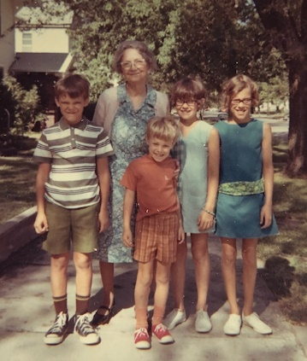 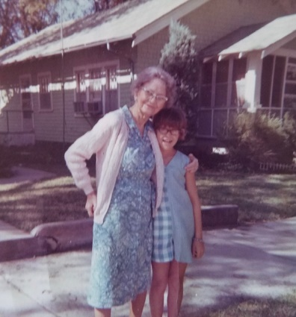 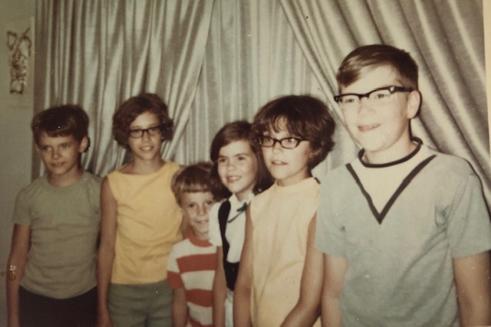

In Hutchinson with Grandmother, and cousins Jim and Jana Kay.

Trip – As we left Hutch we stopped at that Best Western Motel just West of Main on 4th and made a reservation for the Custer, S. Dak, motel. We drove on to Larned and had lunch at a drive-in. We then stopped at Fort Larned. Alan started feeling ill there and we thought maybe he was getting what Jimmy had. If that was it it didn’t last very long as he was feeling better before long. Fort Larned is now a National Park Service Historic Site and is being completely restored. A lot of the work is just getting started. I guess it had been in private hands for many years.

e stopped for a treat along the way and got to Oberlin about 6:30. We had to practice at 7:00 at the church and then we had a little bit to eat afterwards. The kids stayed at the Laidigs. The kids all slept (the girls in their sleeping bags) in the bedroom where we normally sleep. Because of all the relatives the first two nights we slept at a neighbors house.

Sunday was quite a day, of course. Our duet went OK and there were about 49 relatives at the church service. Afterwards Mr. Laidig took the whole group to dinner at the restaurant. I guess it was just about the biggest get together of Laidig relatives that has ever taken place. Ruth met a cousin that she had never seen. I guess it was the only time that the 3 children (Ruth, John & Eldon) had all been together with their families since they had been married. Four of the 6 Musgrave children were there. They have all turned out quite well.

Open house was in the afternoon and evening. Ruth helped serve part of the time. Aunt Lenore (from Miami – Mrs. L’s sister) helped organize things. Mrs. L had gone down to their 50th anniversary 3 years ago and helped. I don’t know how many people stopped by, but it was pretty crowded part of the time.

The thing I remember most about the celebration is the cake. It was white, with white frosting, and was sooo good. I wanted to eat it all. I also remember Mom’s brothers teasing her as they all stood around talking together in the kitchen.

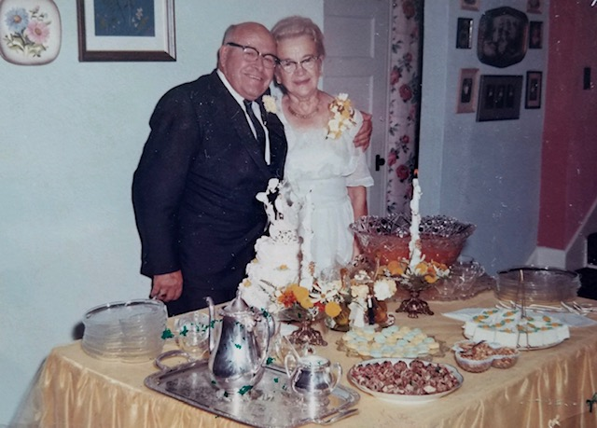 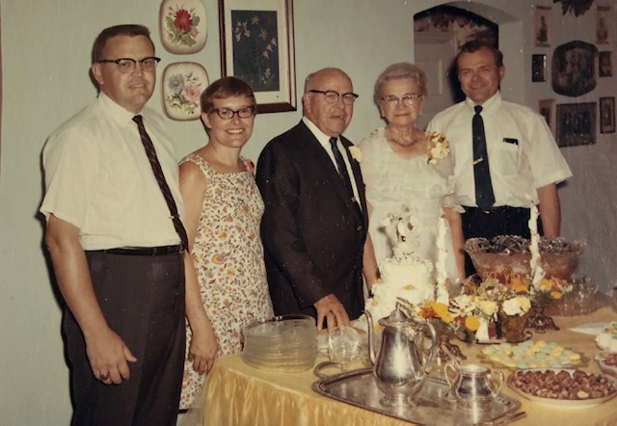

 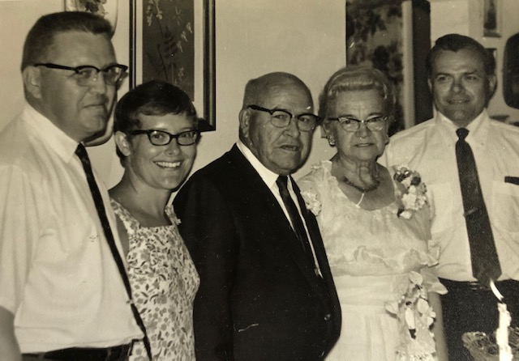

Final picture left to right – Eldon Laidig, Ruth Laidig Smith, Ira Laidig, Minnie Laidig, John Laidig

Mon and Tues the kids went swimming, to the junkyard, museum, etc. like we always do. The County Fair had started Tues so in the evening we went there and the big kids rode the ferris wheel. Don Musgrave (a baker from Portland, Ore – he’s single) and I and (Gary Laidig - a cousin from Los Angeles) went with Mr. L to Rotary on Tues.

Wed AM we got around in fairly good time and made the drive to Custer, SD – about 400+ miles. We stopped at North Platte, Neb and visited Buffalo Bill Cody’s Home. (We had visited his grave last Summer on Lookout Mountain near Denver, Colo). We then drove state highways across Neb. Mr. L knows all that area because of his hail adjusting and he picked out a good route for us that would save time. It took us through sparsely settled cattle country. We got to Custer (in the Black Hills) by dark. We stayed in the same Motel Thurs night also ($25/night).

Thurs we took the Needles Drive after stopping at a lake, and then went to Wind Cave for lunch and the tour. It was the first cave the kids had ever been in. At the bottom of the cave, I discovered that a fellow I lived with when I was a Senior at KU was in our group. We hadn’t seen each other since 1953. In the PM we took a train ride through the mountains on an old steam train. On the way back to Custer we stopped at Mt. Rushmore.

Fri AM we drove to Rapid City for lunch. On the way we stopped at a fixed up gold town called Rockerville. We then drove to Bear Butte and visited some Indian Ceremonial Grounds. We then drove to Deadwood and visited the graves of Wild Bill Hickok and Calamity Jane. Ruth had been there once. We had supper there and then attended the reenactment of the trial of the man who murdered Wild Bill. I guess Wild Bill was Marshall at Abilene, Kans before he went to Deadwood, SD.

After that (10:00 PM) we drove 100 miles on Interstate to Wall, SD where we had another $25 motel. Sat AM we visited the world famous Wall Drug Store and then drove through the Badlands (very fascinating). We drove on to Sioux Falls for supper and did the laundry and then on to a Holaday Inn at Council Bluffs for our last night.

Sun AM we went to a Presbyterian church and then made the long drive on home 460+ miles. We got here just before you called.

 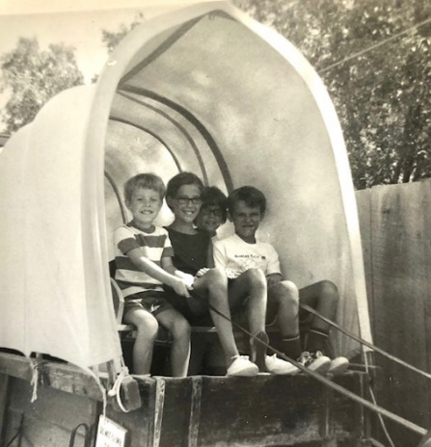

The picture on the left is in Needles, and the one on the right is in Wall, South Dakota.

Everything is OK at work. I’m glad I didn’t try to go to the Pittsburgh meeting last week. It was another wonderful vacation and I’m sure the kids got a lot out of it. Lots of good memories of this trip. Thanks Mom and Dad ☺ Thanks again for everything while we were in Hutchinson. Our plan is to go to Hutchinson by train about the weekend of Dec 27th – after the Christmas music.

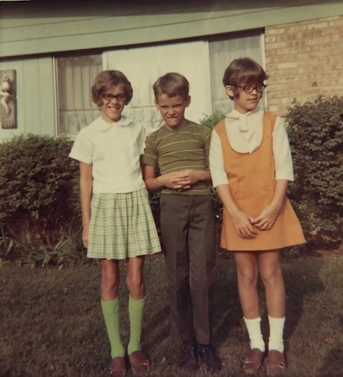

First day of school – September 2

**9-13-69 – Sat PM 5:30 -** It’s a warm weekend here; probably one of the last real warm ones of the year. Ruth has just gone out to do some shopping before the stores close. This afternoon was Lisa’s birthday party. There were seven of them counting Lesle. I took them over to a nearby amusement park for some rides, and then they came back for the gifts and refreshments. Ruth decorated our old kitchen table and the carport and they ate out there. We finally got our new good (and expensive) dining table (thats why the old one was out in the carport). Our old one looked pretty bad and the chairs are all worn out (they were fixed with new replacement seats and backs several years ago) so we feel we deserve the new one. We got the old table when we lived on the hill in Kansas City. The new table should last us as long as we need one and can be used in a dining room someday. We haven’t ordered the new chairs yet

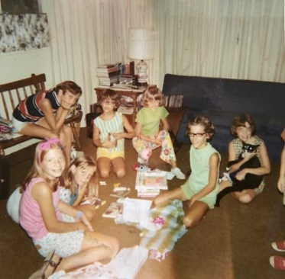 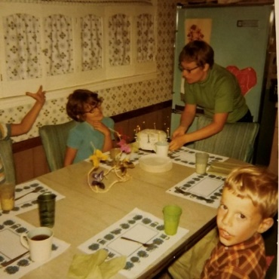 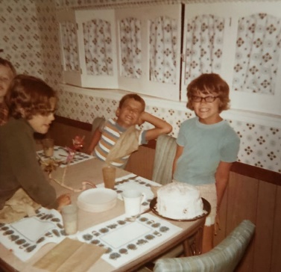 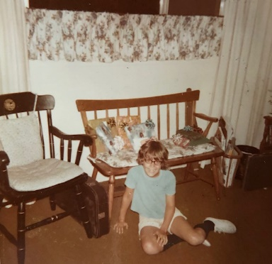

*Lisa’s* birthday pictures. *Again.*

We also are getting a new dryer. Our old one was purchased while we were on Eaton Street in Kansas City, so it lasted about 10 years. It has been repaired several times and a new one is not very expensive. However, these are all the big things we plan to buy this fall until Christmas time when we plan to get a new TV.

Ruth’s choirs start this week. I believe her enthusiasm has dwindled slightly this year, but it’ll pick up once she gets started. As you remember she has to serve a second year as President of the Womens Association. They change about half of their officers the first of the year. I finally painted the sand box and anchored the corners. Its directly under the tree house. We sent dimensions of the tree house to Mr. Laidig so he can repair it when they come in October. At 73! Last night we ate at Howard Johnsons (children under 12 get a birthday dinner free and the waitresses bring a little cake and sing “happy birthday” for your dessert). Thurs night was choir practice for Ruth and I went to a Mission Council meeting in a neighboring suburb. Last Wed night was my monthly Session meeting. Lisa used your money to buy corduroy bell bottom slacks.

We hope your ribs are getting along OK. We think you were lucky. I guess the girls have started band although I haven’t heard much. They have to go to school earlier than they used to (in part because they haven’t passed any of the bond issues, etc. and there are no new schools so the crowding makes for more difficult schedules) and it makes the lunch times a lot more difficult for Ruth. They all used to do their piano practicing before school. Now that is a lot more difficult.

I had a flu shot yesterday and feel a little more tired today. Glad to have your letter and to hear about everything. Hope Aunt Clara and everyone is OK. We’ve always had electric pads. Your pain pill might be Darion – a codeine substitute.

**9-25-69 – Thurs PM 5:30 -** Dear Aunt Clara, Mother, M.J. and Bill, I don’t believe I’ve directed a letter to you first since we got back from vacation. I believe Lisa has written Mother a letter this week. As usual, I meant to write earlier in the week, but just didn’t get it done. I’ve been working a little harder at work (and at night) catching up on some things that I was behind on. I’m now behind on Church work. Next week I have to call on a few people to invite them to church on World Wide Communion Sunday. We’re planning to have a mens quartet at Church sometime this fall.

Ruth and the kids (3 older) are just now arriving home from their choir practice. This is Ruth’s Carol Choir (3rd - 6th grade) – I believe Alan and one other boy are the only boys. Ruth’s older group (the Crusaders – 7th & 8th grade) is going to practice on Sunday AM rather than on Wed evenings. Several of the older kids can’t come on Wed evenings. Tonight is adult choir practice. We have a new regular Thurs night baby sitter this year. She lives across the street so I don’t have to drive and pick her up like I had to do last year.

Ruth has been working hard the last two days in the utility room. We got a new dryer and Ruth has repaired the floor (a lot of the tile was ruined when a pipe broke several months ago) and will paint it. We still haven’t fixed the study into Lisa’s bedroom. The girls bands have started and Alan and the girls continue to take private piano lessons on Mon after school. I had my final dental appointment last Mon night so I hope I’m in shape for at least 6 months. Alan has the next appointment.

My birthday went fine on Tues. We had our usual nice birthday dinner and then I opened my presents. I got a pair of trousers, a shirt, belt, undershirts, and the game Aggravation. We all played the game afterwards. Ruth sometimes surprizes ☺ me with dessert guests on my birthday. This year she had invited the minister and his family but they couldn’t come so we enjoyed the game instead.

Last Sat night was the Couples Club meeting at the Church. It was a treasure hunt and we had to drive out and find clues – each clue telling us where to go for the next clue. There was only a small crowd but we had a lot of fun. Last Sun night Pete Luna (he’s worked for me 6 years) and his wife took Ruth and me out to dinner. We both had baby-sitters for the children. I suppose Hutchinson had big crowds for the fair and you had heavy traffic near your house. Maybe someday I’ll have occasion to be in Hutch at fair time again. As I’ve said our plan is to come to Hutch by train the weekend following Christmas. I’ll probably hear from Mother in a day or so. Hope you’re all OK and write when you can. I got a new sweater and matching pants outfit for casual wear; I wore it to the Church Sat night.

**10-12-69 – Sun 6:15 -** We just got back from the Church a little bit ago, so I’ll start this while Ruth is fixing supper. We went to the Church this afternoon for an ordination service (I’ll enclose the leaflet) of a man, Mr. Robert Rademaker, who has been sponsored by our church. He decided to go into the ministry after working as a salesman for 15 years.

I called you when I didn’t get any more written. Sat - I’ll enclose the bulletin from the ordination. I had a solo with the anthem. There were not too many there but they had only been in the church about 3 years; they left, when he entered seminary, about the time that we came. Last Wed night was Session meeting; we got out about 11:00; our committees are now functioning better so our work is done more efficiently.

Last Thurs I went with four other people to a Mission Council meeting in Evergreen Park. That is a suburb Northwest of here. Ruth went to Senior Choir practice. We have several new high school kids singing in the choir this year, so we’re larger in number than previously. Although we’ve only practiced once, we’re supposed to have a mens quartet to sing a week from tomorrow for Laymens Sunday. We’ve never had a quartet before. I can’t remember when I last sang in a quartet; I think it was when I was in College.

I guess Kansas State has the best football team they’ve had in many years. They just barely lost to Penn State one of the best teams in the country. I believe they play KU this afternoon. A week ago today I went with Alan, and an Armour group, to the Purdue, Stanford football game at Lafayette, Indiana. It was hot and clear and we had a good time. Its about 90 miles down there; we drove to the plant where we boarded one of the two buses that went. I thought it would be fun for Alan to see his football game, and I kinda wanted to see one myself; I think the last time I saw a game was at KU in graduate school.

Your letter came today and it was good to hear that your back is better. Drugs are certainly a problem today. I’ve always said I would like to do some writing someday in this area, especially the relationship between Christianity and drugs. It seems like the ordinary responsibilities of job, family, and church don’t leave the kind of time I need for such things. I think Ruth would also like to have more time for herself.

Today is cloudy, cool and rainy, quite a contrast from a week ago. This morning Ruth had a Dr.’s appointment and then she helped at a second hand store in Chicago Heights that is sponsored by Jones Memorial Center, a Presbyterian related community service organization. After that we met Ruth for lunch at the Kiwanis pancake day tent. Its an annual event but we had never gone before. This afternoon I put up the storm windows and Ruth went shopping. Nothing extra on tomorrow so it will be good to relax.

The Laidigs (the’re down in Indiana this weekend), are coming sometime around noon on Monday; we hope they can stay through the next weekend. Ruth is cleaning out the study so they will have a place. As I’ve told you, the study is to soon become Lisa’s bedroom. I just heard that Kansas State beat KU in football. Next Tues is a big day for Ruth, as its the annual Womens Association Retreat. It will be held at our Church with the women from another Presbyterian Church being invited. Wed night is the annual congregational dinner to discuss and approve the annual budget. In view of inflation, rising taxes, and a new Illinois State income tax it will probably be difficult to raise all the money we would like.

Next Thurs night is choir practice and Fri night the Couples Club is having a square dance. Did Mom and Dad dance? I would have liked to have seen that ☺ I think I told you that Ruth’s older choir now practices on Sun morning rather than Wed night. Her Carol Choir which practices on Thurs afternoons is coming along OK. The first Cherub Choir rehearsal will be shortly.

Everything is about the same at work. The kids are coming along OK in their music and at school, as far as I know. I can’t think of other major things since I wrote last. Hope you’re all fine. Ruth bought a new little tape recorder to help with choirs, the kids practicing, etc.

**10-31-69 – Sat PM -** Dear Aunt Clara, Mother, M.J. and Bill, I called Mother last weekend, but I’ll send the letter to you first since I haven’t sent one to you first for sometime. Today has been cloudy and damp but it hasn’t rained any. We took our time getting around this morning as we didn’t have anyplace to go. One of the girls friends stayed overnight with them after going out trick or treating with them yesterday evening.

This afternoon the kids all (this is the first year that Andy can go) went to their Childrens theater. I remember these, sitting on the floor in a big noisy room with a lot of other kids. Ruth, Andy and Lisa are now out shopping. I just heard that Kansas State lost to Missouri in football. Thats too bad; I’ve been pulling for K State since KU is out of the running this year. Well, anyway, it appears that K State has their best football team in 25-30 years or more.

Alan is thrilled today since we finally got his crystal radio kit put together. He can get 2 or 3 different stations, and it is fixed so he can listen while he is in bed. He got the kit last Christmas but we just never got it put together. He put most of it together, and I helped put up the aerial. We had to order a part that he had lost, or else it didn’t come with the kit.

I don’t think I wrote that we had some good pictures from the trip, including some from the Laidigs 50th wedding anniversary. I’m sure you and Mother will enjoy the anniversary pictures. I’ll get some of them sent before long so you folks can get any you want and send them back. Tomorrow afternoon I’m going into the city to attend a medical meeting. I’ll go in and back on the train. Ruth will attend a chorus rehersal in the afternoon which I will miss; I went last Sun when Ruth missed. Its a Chicago Heights chorus which Ruth and I sang in 2 and 3 years ago. The concert is in Dec.

This Tues night the Lt. Governor of Illinois, Paul Simon, will speak at our church on world hunger; the meeting is sponsored by our Womens Association. Next Thurs night Ruth will have regular choir practice and I’ll attend that monthly Presbytery meeting that I go to as a representative from our church. I was glad to receive Mother’s letter today, but was sorry that you haven’t been feeling so well recently. I’m sure that your good attitude will keep you going. I guess that Mr. Laidig had some angina-like chest pains a few years ago when he was under stress. After he got over the stress I think the chest pains left. I think he took some nitroglycerin, but hasn’t had to since. Thats wonderful that you now have a women to stay with you; I’m sure that will relieve some of the stress. Don’t take any more nitroglycerins than you have to.

It sounds like you’ve had a good meeting at the church. I think the Presbyterian Church is realizing the need for more evangelism; like in most other big denominations, membership and giving is down. As Mother says, many of those at the meetings are already members. The problem is how to reach those who won’t come into the church. A week ago last night was Family Fun Night at the Church. It was sponsored by the Womens Association in order to raise money for the Association. There was a money raising dinner and many money raising booths, etc., including many things to sell. They raised a $1000 and still have some things to sell. The women make most of the things they sell.

A week ago today Ruth and I went with one of the Jr. Dept teachers, and 25 kids, to attend the Ice Follies at the Chicago Stadium in the City. Everyone had a fine time; it was certainly an extravaganza. We all went in a bus that was hired. Ruth has started to give Andy piano lessons. He’ll take his on Mon at the same time that the big kids go take theirs from Mrs. Aageson. The girls are doing fine on the Oboes. Ruth’s Carol Choir sang last Sun. There was a big crowd and everything went fine. Her older choir sings next Sun and her Cherubs (youngest) have started to rehearse (Andy is in the Cherubs) for their singing on Thanksgiving Sunday. Ruth says that Alan has a good soprano voice and can sing higher than the girls.

I think Ruth is worn out today after making elaborate costumes for Halloween. Andy was a Pink Panther, Lisa was a gypsy, Lesle was H.R. Pufnstuf (a new Sat AM TV character) and Alan was Snorky the elephant (another TV character). I stayed at home and answered the door while Ruth took all of them out trick or treating.

  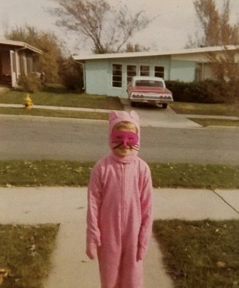 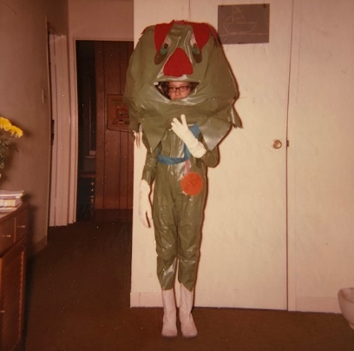

The elaborate costumes.

Mr. Laidig did a good repair job on the tree house and the kids can now go up safely. I had a meeting last Wed night of the old and new officers of the Open Door Adult s.s. class. I’ve been President the past year; I think we have some good new officers. I’ll have more time now to devote to my regular Session duties. I have one more year (1970) on the Session. We had our first Adult Discussion group meeting a week ago last Tues night. We hope to expand them. They will meet in homes and will discuss various subjects.

Again, we hope you’re feeling better and that the new medicines will help. We still plan to go to Hutchinson the weekend after Christmas. Our mens quartet (see enclosed leaflet) went OK on Oct 19, 1969.

**11-23-69 – Mon PM -** We’re waiting for the dishes to be finished by Lisa so we can go to the Library. We usually go on Mon evening although we don’t go every week. I’ll enclose the pamphlet describing our Library. I think I told you that we went to the opening of the new addition. We have a beautiful Library; it is one of the best suburban libraries, and has one of the highest circulation rates in the State.

Today is warmer and rainy. We had a little snow a couple of times but it melted when it warmed up. Tomorrow night is our small discussion group. Wed night is the sphaghetti dinner at church; it is the High School Group’s main way of raising money for their annual retreat in Wisconsin. Several of the high school kids are singing in the adult choir; more than have sung in previous years. Thurs night is regular choir practice. Yesterday Ruth’s older choir sang at the morning worship service. Her Cherub Choir will sing next Sun for the Thanksgiving Worship Service. The Inter-Faith Thanksgiving Eve service will be held in our Church a week from Wed night; there will be a joint choir.

Yesterday afternoon I went to rehersal (couldn’t get a baby sitter so Ruth stayed at home) for the chorus that sings with the Chicago Heights Symphony at their Dec concert. I guess the Symphony is in the red. We don’t have tickets ourselves since they are so expensive. After the rehersal I called on the last person on the every member canvass list (10 people) that another man and I had. We did most of our calling a week ago yesterday afternoon on Stewardship Sunday. Ruth has all the new officers for the Womens Association for 1970. As you know she continues on for one more year. We have a high school boy coming to paint the tree house. Thats another way they have of raising money for their Retreat.

Wed – We’re ready now to go to the Sphagetti Dinner. We had snow last night and it was slow going to work this AM. Thats an interesting article I’m enclosing about John Alden. They live in a Northern suburb. Ruth didn’t go to the small discussion group last night since we couldn’t get a baby sitter. Last Fri night I brought food in rather than eating out. Sat I got ready for a magic show at Couples Club that evening at church. We were hostesses with the Reifs and he did a lot of calling so there was a good sized crowd. I did some tricks I had never done or had not done in a long time and we all had a lot of fun. Hope you’re all OK and glad to hear that Aunt Clara is feeling better.

**12-19-69 – Thurs 5:40 -** We’ve been very busy, and I just haven’t gotten a letter off sooner. Ruth and the kids are just now arriving home from choir practice. One of the kids ran, fell, and cut her head enough to require 4 stitches. The floor is so slick at church, and Ruth is always telling the kids not to run. We always tell the kids at home to not run in the house since it doesn’t take much of a hit against the edge of furniture to split the skin on your head. Alan did that once in a store in Decatur.

We have reservations on the San Francisco Chief (assuming there won’t be a train strike – I guess the’re getting it settled) from Joliet to Newton on Dec 26th. The other train goes at about the same time and goes through Hutchinson, but it does not have any reserved seats and the day after Christmas is probably about there busiest day of the year. We haven’t heard yet on a reservation from Newton to Joliet on Dec 29. (I’m trading my vacation day on the Friday after New Years for Dec 29th). By going this way we’ll have to get from Newton to Hutch and vice versa. You folks check and see if a Westbound bus waits in Newton until the Chief arrives and then heads West through Hutchinson and vice versa, is there an Eastbound early morning bus which meets the Chief in Newton.

The kids will enjoy the daytime rides more than a nightime ride on the El Capitan like I did. There are just the 3 trains to Newton and to Hutch. We’ve had good weather recently, but I think snow is predicted for the weekend. We got our color TV set (Zenith Table Model) and, of course, the kids are thrilled. Yes we were!

Everything generally is about the same, the usual things, etc. Last Mon night I had a committee meeting. Tues night we had the small discussion group. Last night I had rehersal for the chorus, Ruth had PTA and circle. Tonight Ruth goes to choir practice at church and I go to Mission Council at the Jones Memorial Community Center in Chicago Heights. Tomorrow night we’ll both go to the chorus and orchestra dress rehersal. The concert is next Sun afternoon. I’m looking forward to some nights at home before Christmas.

Everything is about the same at work – all the responsibility I want at this time. I guess we’ll have to get our Christmas tree in a few days. Ruth hasn’t started on the Christmas Cards as yet. We hope that everyone in Hutchinson is getting along OK. Lisa went with her American Baptist friend (Janet) to their service last Mon night. I believe it was the Dibbles? Who were at your church once I believe. The kids (and we’re all) are excited about going to Hutch. Love, Carroll & family

 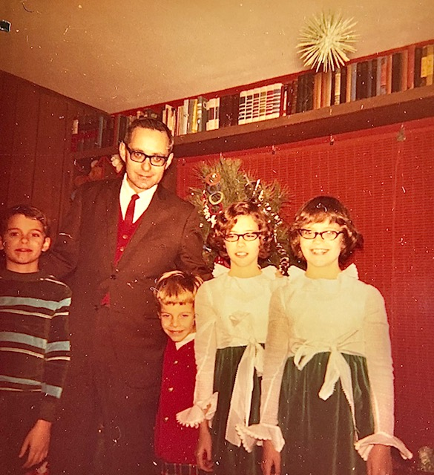

Merry Christmas from 1969!

Note the paneling Dad put up, the shelving unit they had built and installed, and the bright orange vinyl slat roll-up shade. Also, the same itchy dresses for the girls as last year ☺